Arrays and linear search
Y11 - Cambridge IGCSE 0478 | Paper 2 | 8.2 Arrays | Student booklet
Name: _______________________________ | Date: _____________

This booklet has everything you need for the lesson in one place. Work through it in order:
- Learn sections show the key slides. Read them carefully - they explain the ideas and show worked examples.
- Task sections are where you practise. Each task uses what the slides just before it taught you.
- Tasks 1 to 4 use pseudocode; Tasks 5 to 9 are VB.NET at the computer. Questions are based on real Cambridge 0478 Paper 2 questions.
Do Task 1 from memory before you turn the page.
Task 1 Retrieval check [5 marks]
From memory. Write TRUE or FALSE for each statement. If it is false, write a correct version.
# | Statement | True / false | Correction if false
1 | One array can store a mixture of integers and strings.
2 | After DECLARE Marks : ARRAY[1:30] OF INTEGER, the first element is Marks[1].
3 | In VB.NET, Dim Marks(30) As Integer creates exactly 30 elements.
4 | A linear search always checks every element, even after the item is found.
5 | When totalling the values in an array, the total must be set to 0 before the loop.

Learn One-dimensional arrays
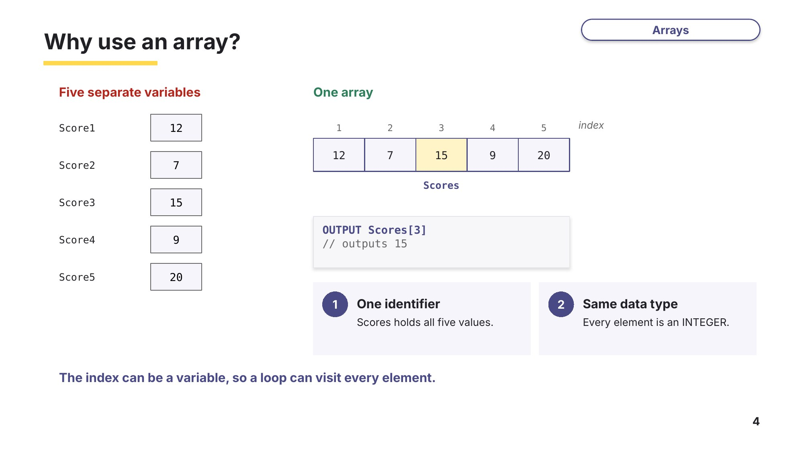
Slide 4 - Why use an array?
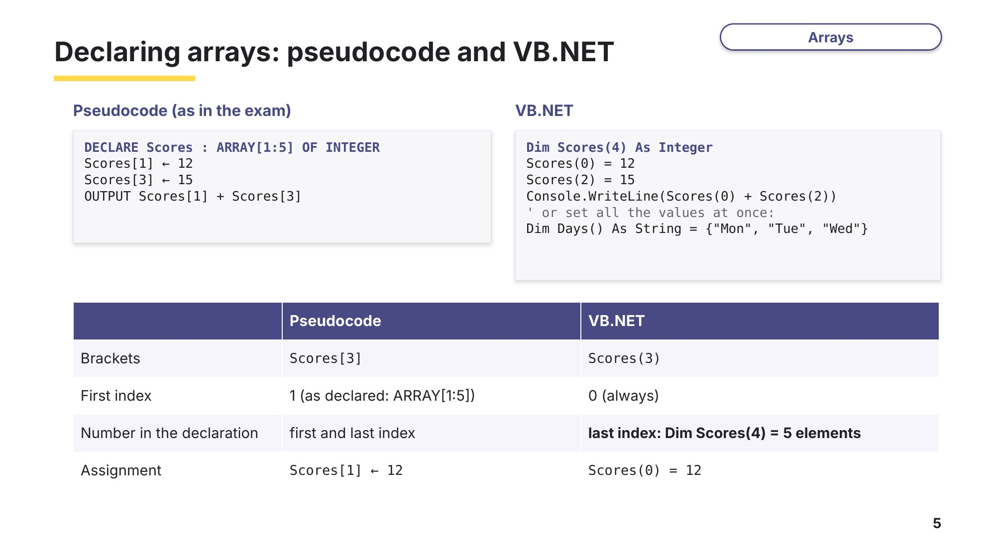
Slide 5 - Declaring arrays
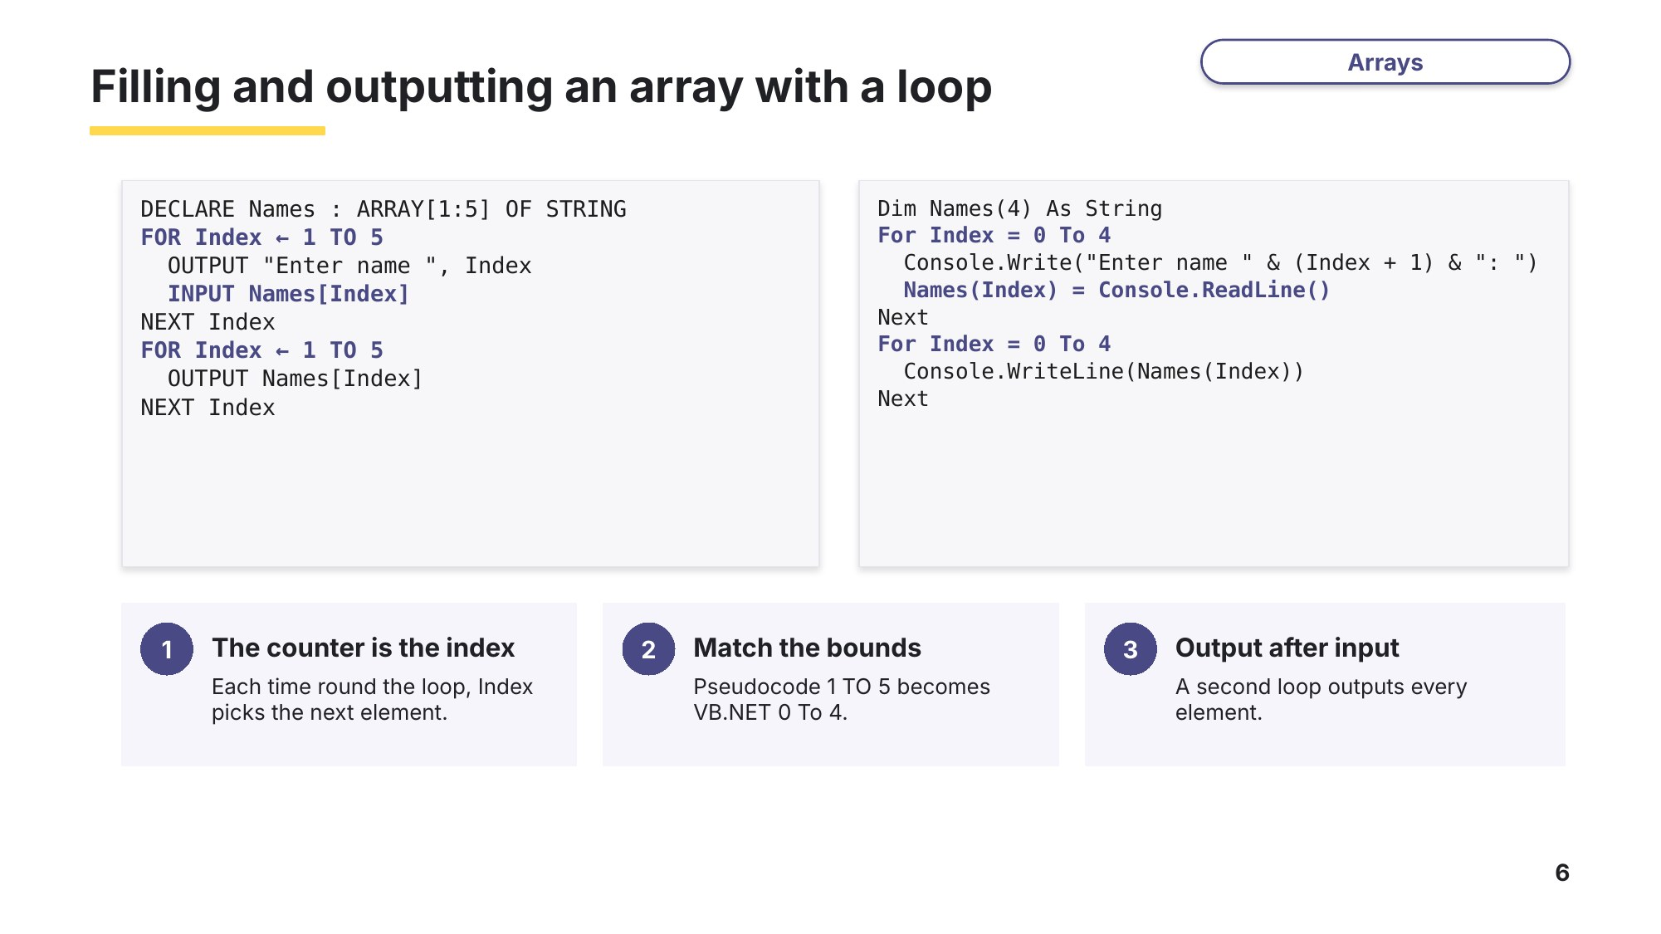
Slide 6 - Filling and outputting an array

Task 2 Arrays in pseudocode [16 marks]
(a) The array Temps stores the midday temperature for each day of one week. [4]
Exam-style
Index | 1 | 2 | 3 | 4 | 5 | 6 | 7
Temps | 21.5 | 24 | 19.5 | 26.5 | 23 | 18 | 22.5

(i) State the value of Temps[4]. [1]

(ii) State the index of the lowest temperature. [1]

(iii) Write a pseudocode statement to change the third temperature to 20.0 [1]

(iv) Explain why the statement OUTPUT Temps[8] would cause an error. [1]

(b) Write a pseudocode statement to declare an array Names that can store 30 student names. [2]

(c) Write pseudocode to input 30 names into the array Names. Use a loop and a suitable prompt. [3]

(d) This algorithm uses a count-controlled loop to input 10 names and store them in the array Names.
FOR Count ← 1 TO 10
OUTPUT "Please enter a name"
INPUT Name
Names[Count] ← Name
NEXT Count
Rewrite the algorithm using a condition-controlled loop that does the same job. [4]
0478/21 May/June 2025 Q3

(e) Write pseudocode to output the 30 names stored in Names in reverse order, starting with the last name. [3]

Learn Totalling and counting with arrays
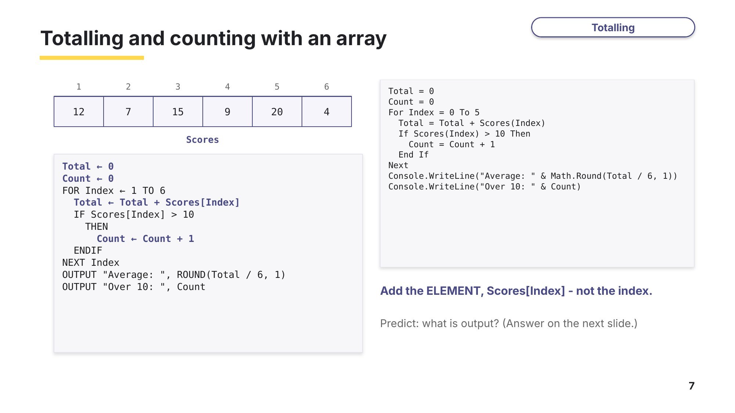
Slide 7 - Totalling and counting
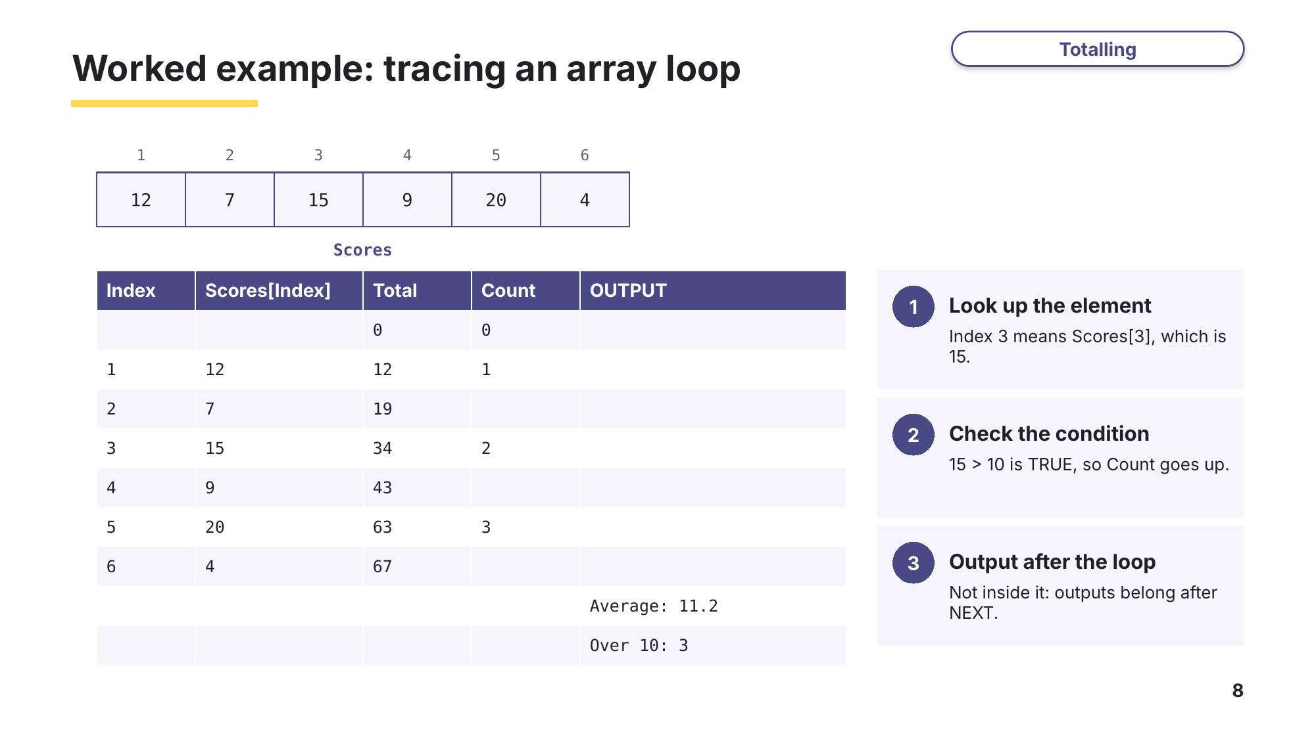
Slide 8 - Tracing an array loop
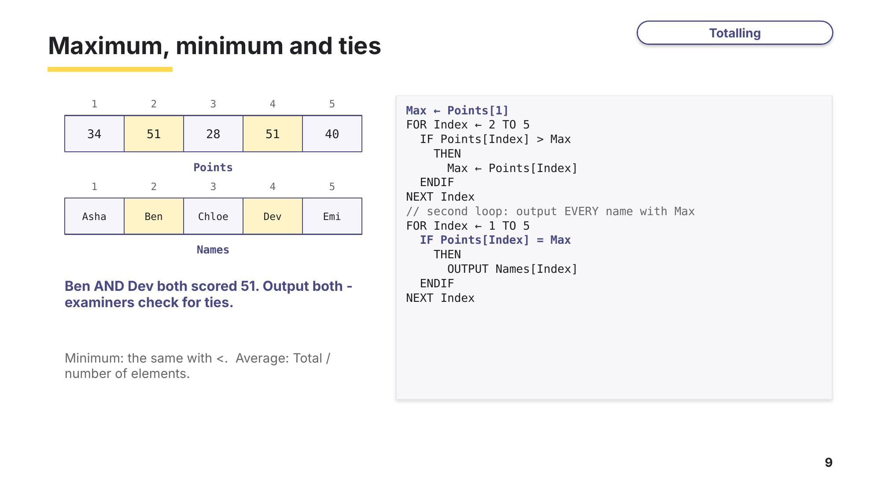
Slide 9 - Maximum, minimum and ties

Task 3 Totalling and counting with arrays [27 marks]
(a) The one-dimensional array A[] stores 50 integers. This algorithm counts how many of the values are zero and totals the values that are not zero.
0478/21 Oct/Nov 2024 Q6
01 DECLARE A[1:50] : INTEGER
02 DECLARE C : INTEGER
03 DECLARE I : INTEGER
04 DECLARE T : INTEGER
05 I ← 0
06 .....................................
07 FOR C ← 1 TO 50
08 IF A[C] .............................
09 THEN
10 T ← T + 1
11 ELSE
12 I ← I + A[C]
13 ENDIF
14 .....................................
(i) Complete lines 06, 08 and 14. [3]
Line | Completed line
06
08
14

(ii) Write pseudocode to output, with suitable messages, the number of zeros in the array and the total of the non-zero values. [3]

(iii) Suggest meaningful identifiers for the array A and the variables T, C and I. [3]
Identifier | Meaningful identifier
A
T
C
I

(b) The array Rainfall stores the rainfall in millimetres for each day of one week.
Exam-style
Index | 1 | 2 | 3 | 4 | 5 | 6 | 7
Rainfall | 4.5 | 12.0 | 0.0 | 18.5 | 7.0 | 25.5 | 10.0
Total ← 0
WetDays ← 0
Wettest ← 1
FOR Day ← 1 TO 7
Total ← Total + Rainfall[Day]
IF Rainfall[Day] > 10
THEN
WetDays ← WetDays + 1
ENDIF
IF Rainfall[Day] > Rainfall[Wettest]
THEN
Wettest ← Day
ENDIF
NEXT Day
OUTPUT ROUND(Total / 7, 1), " ", WetDays, " ", Wettest
(i) Complete the trace table for the algorithm. [5]
Day | Total | WetDays | Wettest | OUTPUT

(ii) Describe what the variable Wettest stores when the algorithm ends. [2]

(c) This algorithm should find and output the largest and smallest values in the array List[], which stores 1000 numbers.
0478/22 May/June 2024 Q7
01 Max ← List[1]
02 Min ← List[1]
03 FOR Counter ← 2 TO 1000
04 IF List[Counter] < Max
05 THEN
06 Max ← List[Counter]
07 ENDIF
08 IF List[Count] < Min
09 THEN
10 Min ← List[Counter]
11 ENDWHILE
12 NEXT Counter
13 OUTPUT "Maximum value is ", Max
14 OUTPUT "Minimum value is ", Min
(i) Give a line number for each of these types of statement: an assignment statement, a selection statement and an iteration statement. [3]
Type of statement | Line number
Assignment
Selection
Iteration

(ii) Identify the line numbers of the three errors and suggest a correction for each. [3]
Line | Correction

(d) The array Marks[1:30] already stores the test marks for a class. Write pseudocode to calculate and output the average mark, then count and output how many students scored above the average. [5]
Exam-style

Learn Check your Task 3(a) answers
Only look at this slide once you have finished Task 3. Mark part (a) against the official marking points.
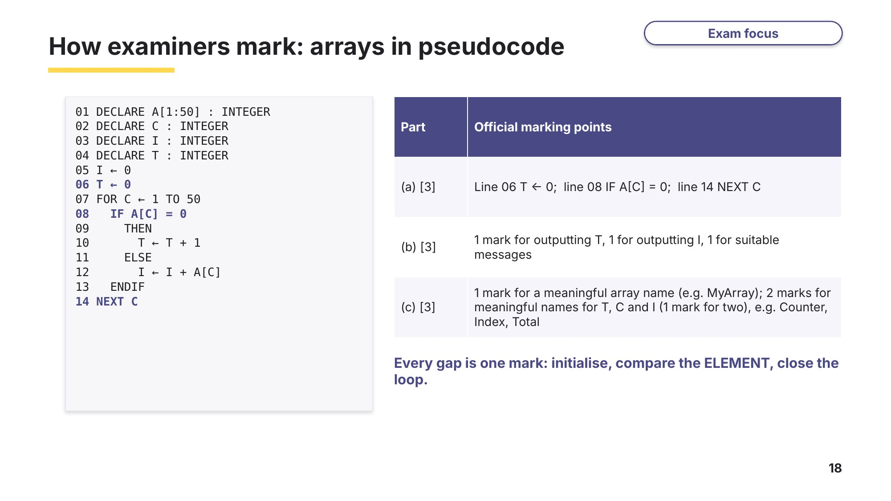
Slide 18 - How examiners mark: arrays in pseudocode

Learn Linear search
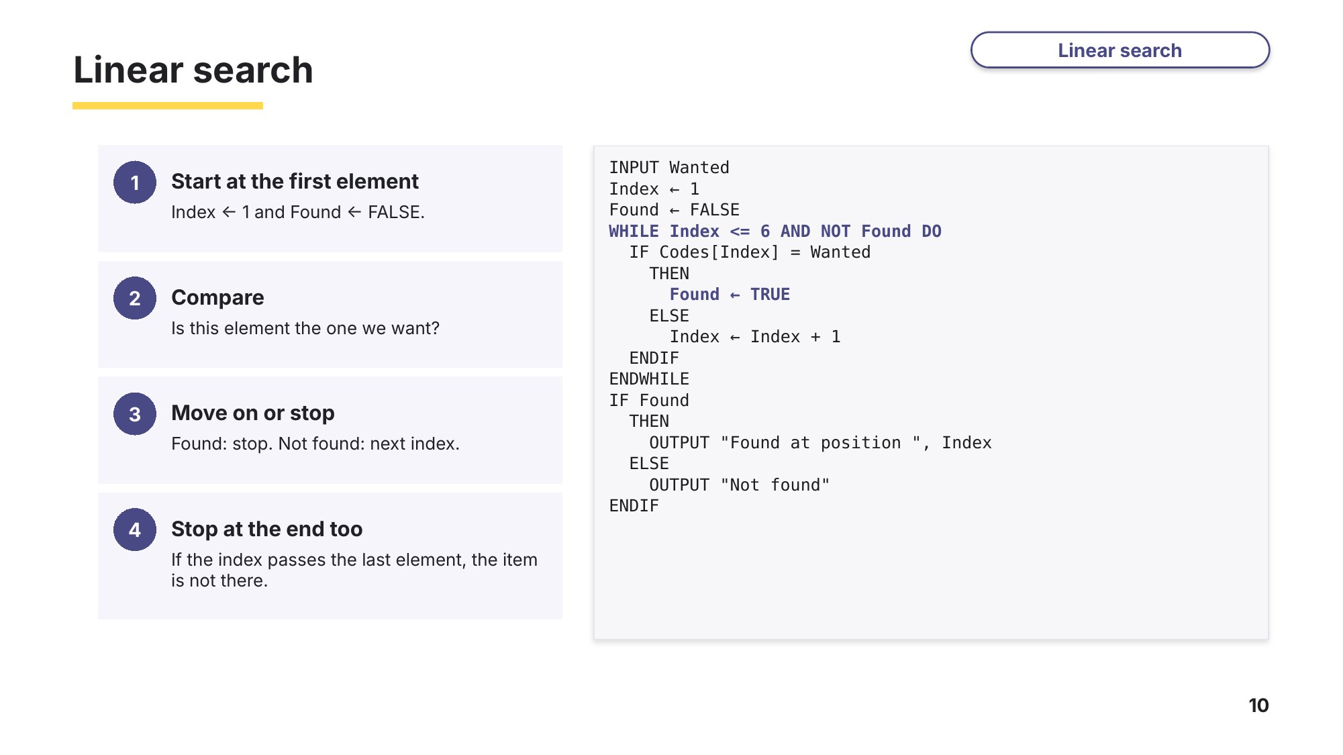
Slide 10 - Linear search
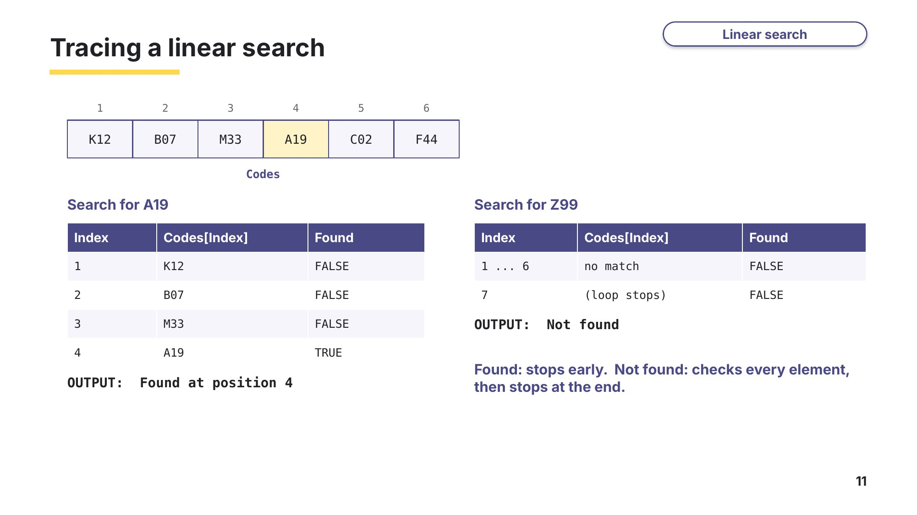
Slide 11 - Tracing a linear search
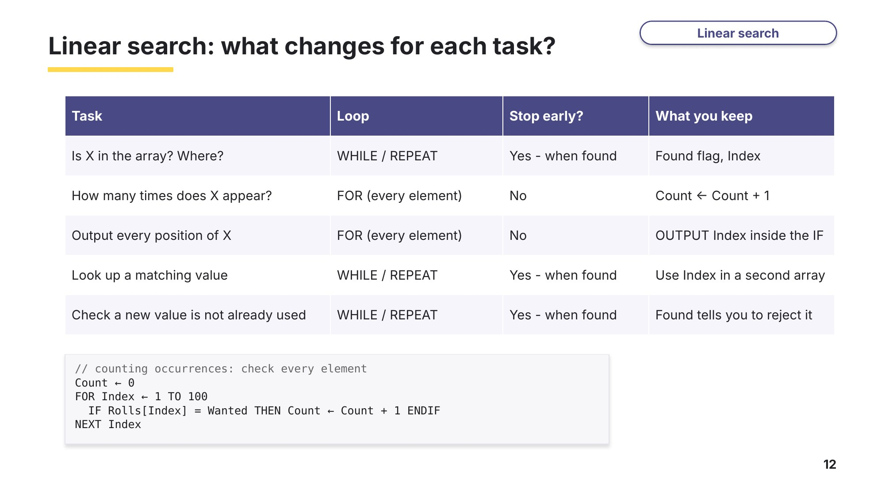
Slide 12 - What changes for each task?
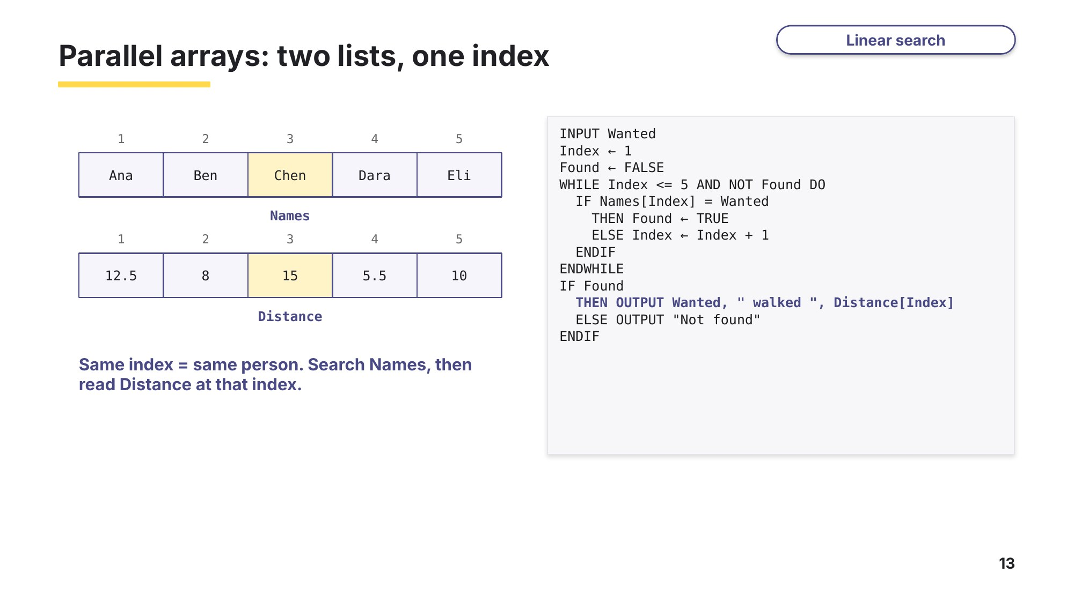
Slide 13 - Parallel arrays

Task 4 Linear search [21 marks]
(a) The arrays Letters and Words store the first 13 letters of the alphabet and the word used to represent each letter on the radio.
Based on 0478/21 May/June 2023 Q7 (the original is a flowchart that uses one 2D array)
Index | 1 | 2 | 3 | 4 | 5 | 6 | 7 | 8 | 9 | 10 | 11 | 12 | 13
Letters | A | B | C | D | E | F | G | H | I | J | K | L | M
Words | Alpha | Bravo | Charlie | Delta | Echo | Foxtrot | Golf | Hotel | India | Juliett | Kilo | Lima | Mike
REPEAT
OUTPUT "Enter a letter from A to M"
INPUT Letter
Pointer ← 1
WHILE Letters[Pointer] <> Letter DO
Pointer ← Pointer + 1
ENDWHILE
OUTPUT "Letter ", Letter, " is represented by ", Words[Pointer]
OUTPUT "Another letter? (Y or N)"
INPUT Choice
UNTIL Choice = 'N'
(i) Complete the trace table using the input data: F, Y, D, N [4]
Pointer | Letter | Choice | OUTPUT

(ii) Name the standard method used in the algorithm. [1]

(iii) Explain what would happen if the user entered the letter Z. [2]

(b) The array OldList[] stores the passwords a user has used before. The value "XXXX" is stored in the first unused element. This algorithm should check that a new password has not been used before, and if it has not, store it.
0478/23 Oct/Nov 2023 Q5
01 OUTPUT "Enter your new password "
02 INPUT NewPassword
03 Posn ← 1
04 Found ← FALSE
05 REPEAT
06 IF Password = OldList[Posn]
07 THEN
08 Found ← TRUE
09 ELSE Posn ← Posn + 1
10 ENDIF
11 UNTIL Found AND OldList[Posn] = "XXXX"
12 IF Found
13 THEN
14 OUTPUT "Password has been used before"
15 ELSE
16 INPUT "New password accepted"
17 OldList[Posn] ← NewPassword
18 ENDIF
(i) Identify the three errors in the algorithm and suggest a correction for each. [3]
Line | Correction

(ii) Explain why "XXXX" is stored in the array, and what happens to it when a new password is accepted. [2]

(c) The array StockCode[1:50] stores the codes of the products in a shop. Write pseudocode to input a code and search the array for it. Output the position of the code, or "Code not found". The search must stop as soon as the code is found. [5]
Exam-style

(d) The array Rolls[1:100] stores the results of 100 rolls of a dice. Write pseudocode to input a number from 1 to 6 and output how many times that number was rolled. [4]
Exam-style

Learn From pseudocode to VB.NET
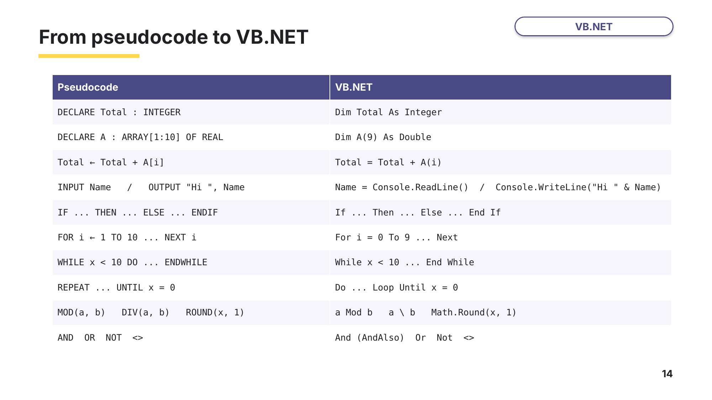
Slide 14 - Pseudocode to VB.NET
Task 5 VB.NET: complete the code [9 marks]
Open Task5_SponsoredWalk.vb. The arrays store the name of each walker and the distance they walked in km. The program should output the total distance, the average distance rounded to one decimal place, and how many walkers walked at least 10 km. Remember: VB.NET arrays start at index 0.
Module Module1
Sub Main()
' Data for the sponsored walk - already stored, do not change
Dim WalkerName() As String = {"Ana", "Ben", "Chen", "Dara",
"Eli", "Fah", "Gus", "Hana"}
Dim Distance() As Double = {12.5, 8.0, 15.0, 5.5, 10.0, 20.0, 9.5, 14.0}
Dim Total As Double
Dim LongWalks As Integer
Dim Index As Integer
' Fill in the gaps (1) to (6), then run the program
Total = ..(1)..
LongWalks = 0
For Index = 0 To ..(2)..
Total = ..(3)..
If Distance(Index) >= 10 Then
..(4)..
End If
Next
Console.WriteLine("Total distance: " & Total & " km")
Console.WriteLine("Average distance: " & ..(5).. & " km")
Console.WriteLine("Walkers who walked at least 10 km: " & ..(6)..)
End Sub
End Module
(a) Write the code for each gap. [6]
Gap | Code
(1)
(2)
(3)
(4)
(5)
(6)

(b) Predict the three lines the program will output. Then type your gaps into the program, run it and check. [3]
Output line | My prediction | Actual output
Total distance
Average distance
At least 10 km

Task 6 VB.NET: find and fix the bugs [10 marks]
Open Task6_QuizScores_Bugs.vb. This program should store 10 quiz scores from 0 to 50, output the average score and the number of passes (25 or more), then search for a score. It contains five bugs, on the lines marked A to E. Each one is a mistake that examiners report every year.
Module Module1
Sub Main()
' Stores 10 quiz scores (0 to 50), outputs the average and the number of passes,
' then searches for a score. This program contains FIVE bugs, marked A to E.
Dim Scores(9) As Integer
Dim Total As Integer
Dim Passes As Integer
Dim Index As Integer
Dim Search As Integer
Dim Position As Integer
For Index = 1 To 10 ' line A
Console.Write("Enter score " & Index & ": ")
Scores(Index) = Console.ReadLine()
If Scores(Index) < 0 Or Scores(Index) > 50 Then ' line B
Console.Write("Score must be 0 to 50. Enter again: ")
Scores(Index) = Console.ReadLine()
End If
Next
Total = 0
Passes = 0
For Index = 0 To 9
Total = Total + Index ' line C
If Scores(Index) >= 25 Then
Passes = Passes + 1
End If
Next
Console.WriteLine("Average score: " & Total \ 10) ' line D
Console.WriteLine("Number of passes: " & Passes)
Console.Write("Enter a score to find: ")
Search = Console.ReadLine()
Position = 0
While Scores(Position) <> Search ' line E
Position = Position + 1
End While
If Position < 10 Then
Console.WriteLine("First found at position " & Position)
Else
Console.WriteLine("Score not found")
End If
End Sub
End Module
Test data: enter 30, 55, 60, 12, 25, 41, 7, 50, 33, 19, 24, 38 (55 and 60 are invalid), then search for 41. Run it again and search for 44.

For each bug, describe what goes wrong when the program runs, and write the corrected line. Fix the bugs one at a time and run the program after each fix. [10]
Line | What goes wrong | Corrected line
A
B
C
D
E

Learn Check your Task 6 answers
Only look at these slides once you have run and fixed the program in Task 6.
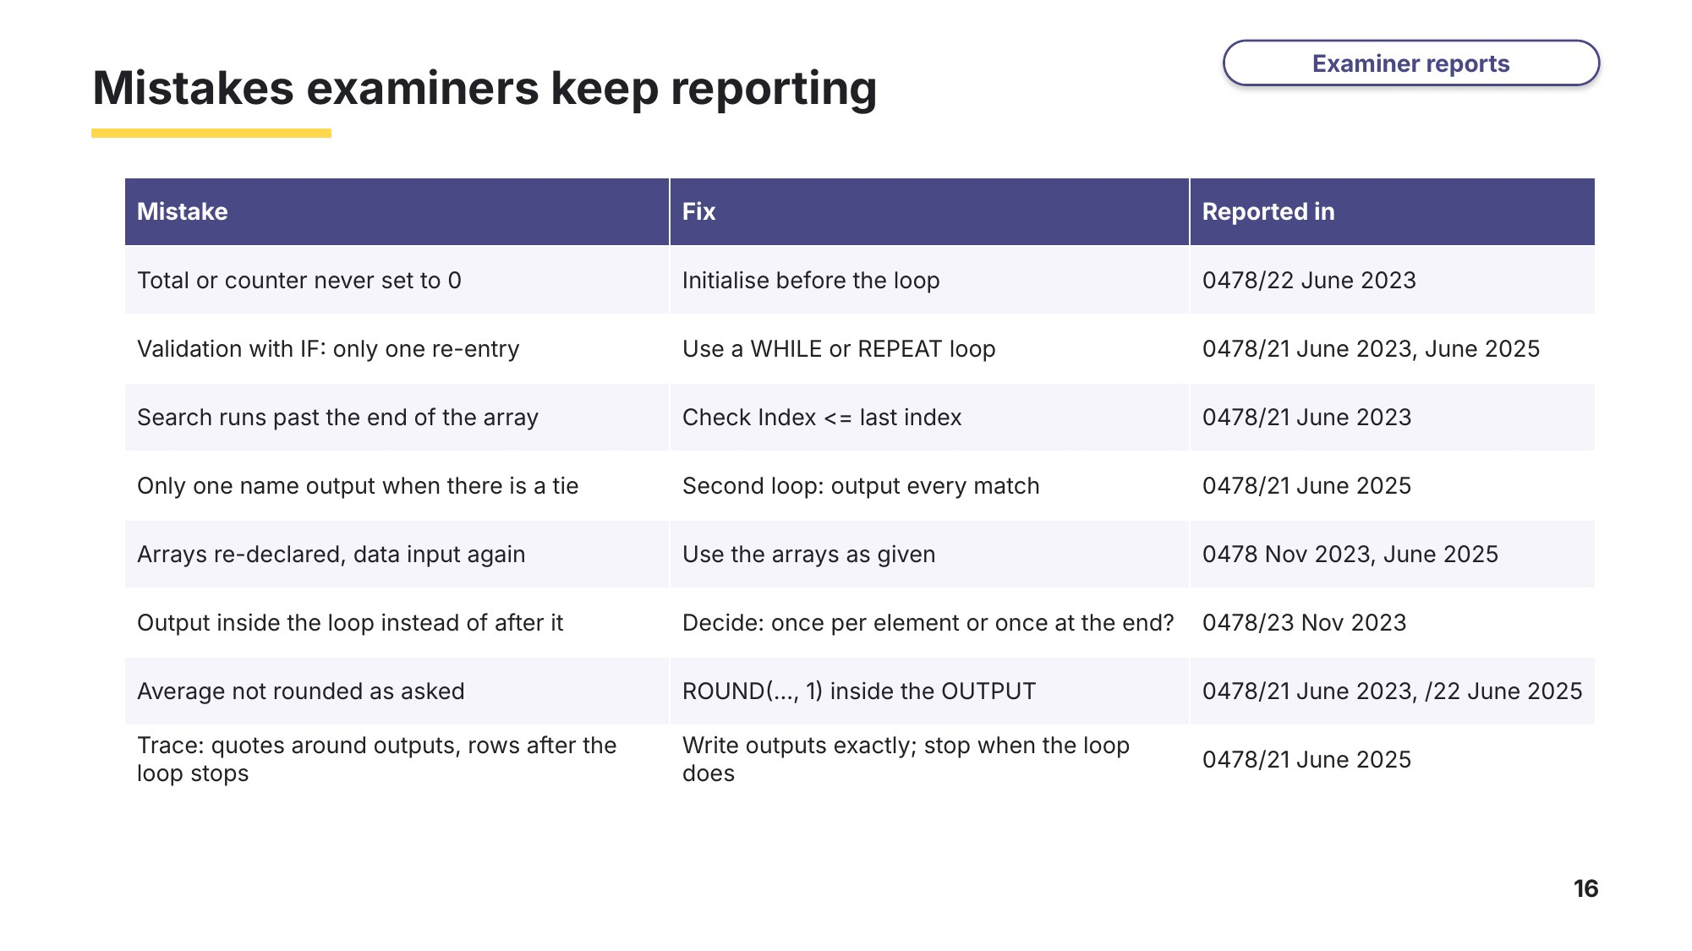
Slide 16 - Mistakes examiners keep reporting
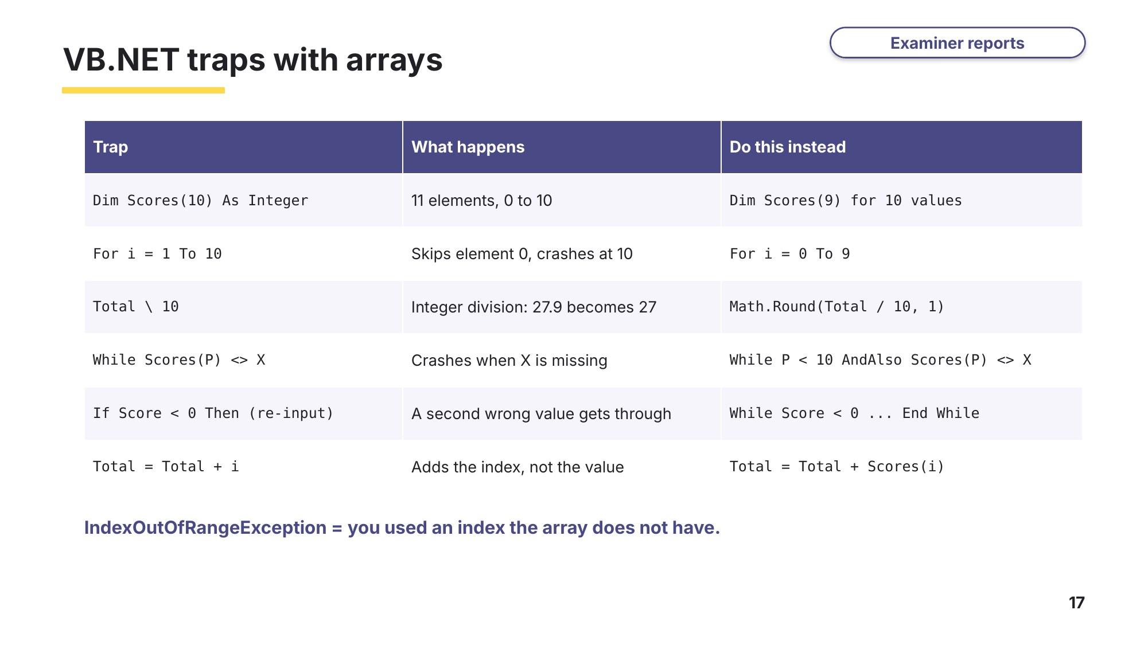
Slide 17 - VB.NET traps with arrays

Learn The Paper 2 programming question
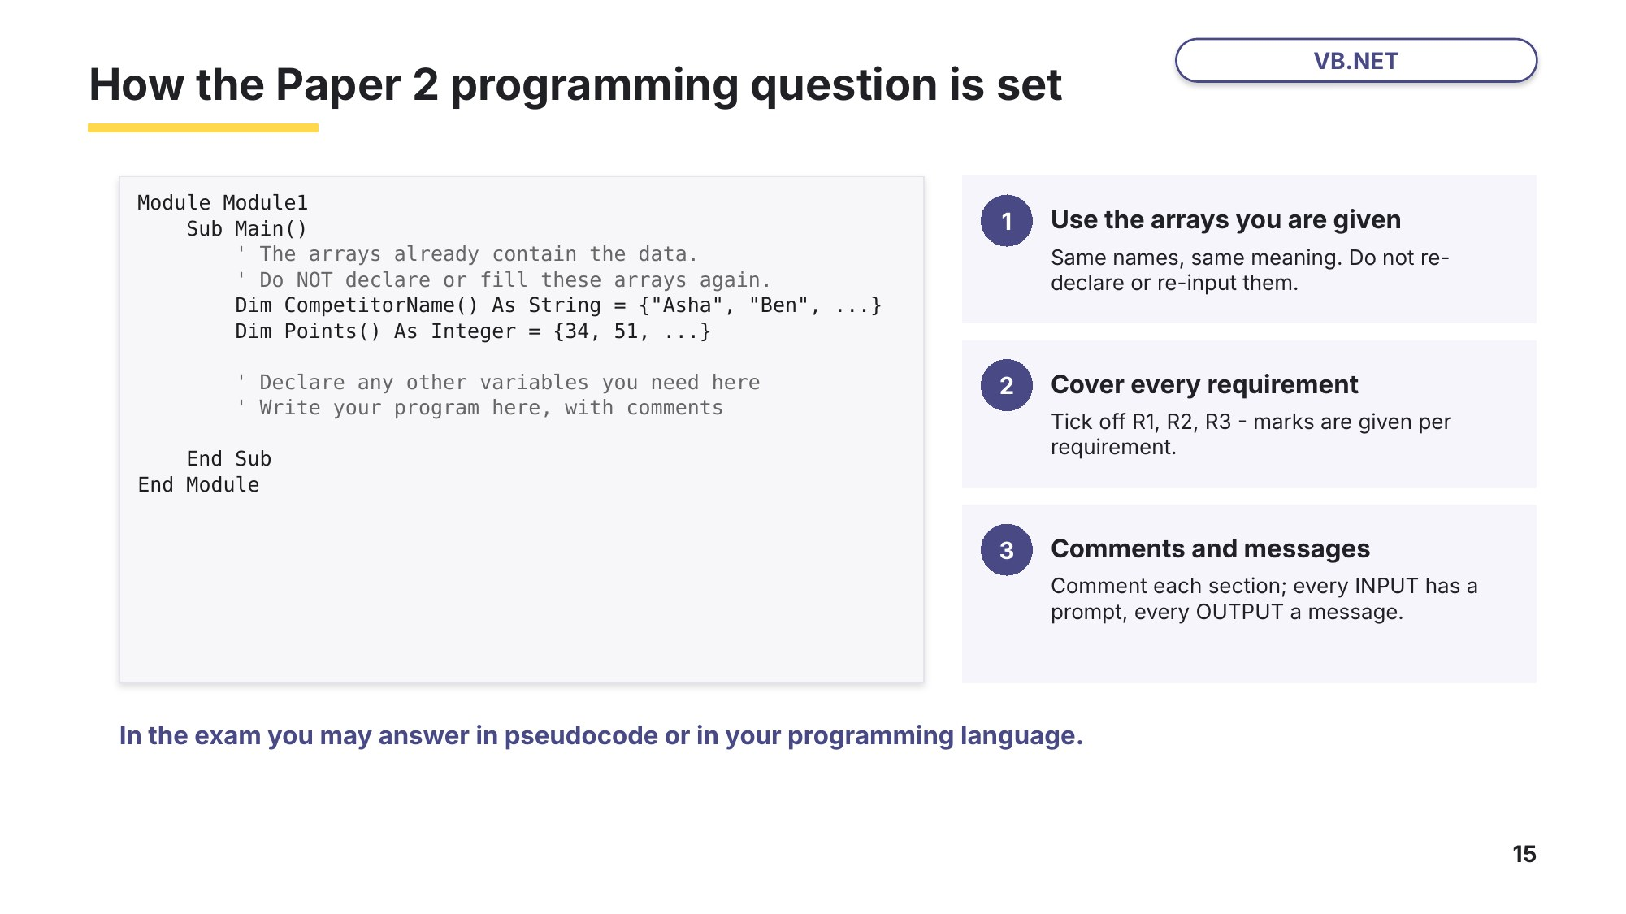
Slide 15 - How the question is set
Task 7 VB.NET: sports day [14 marks]
Open Task7_SportsDay.vb. The arrays CompetitorName and Points already contain the results for 10 competitors: CompetitorName(0) scored Points(0), and so on. Do not declare or fill these arrays again. Write your code where the comments show.
In the style of the 0478 Paper 2 programming question (e.g. 0478/21 May/June 2025 Q11 and Oct/Nov 2024 Q11)
Module Module1
Sub Main()
' Sports day results - the arrays already contain the data.
' Do NOT declare or fill these arrays again.
Dim CompetitorName() As String = {"Asha", "Ben", "Chloe", "Dev", "Emi",
"Finn", "Gita", "Hugo", "Isla", "Jon"}
Dim Points() As Integer = {34, 51, 28, 51, 40, 19, 45, 37, 51, 22}
' CompetitorName(0) is Asha and Points(0) = 34 is Asha's score, and so on.
' Declare any other variables you need here
' (a) Output each competitor's name with their points
' (b) Calculate and output the total and the average points (one decimal place)
' (c) Output the highest score and the name of EVERY competitor with that score
' (d) Let the user search for a competitor by name until they type END
End Sub
End Module
(a) Output each competitor's name and points. [2]
(b) Calculate and output the total points and the average points, rounded to one decimal place. [3]
(c) Output the highest score and the name of every competitor who scored it. More than one competitor may have the highest score. [4]
(d) Allow the user to search for a competitor by name. Output their points, or a message if the name is not found. Keep asking for names until the user types END. [5]
Test: search for Dev, Zara and isla, then type END. Before you run it, predict:
Question | Prediction | Actual
Average points
Highest score and who scored it
What happens when you search for isla (lower case)?

Task 8 VB.NET: library scenario [15 marks]
Exam conditions: 20 minutes. Open Task8_Library.vb.
Written in the format of the 15-mark 0478 Paper 2 programming question
A school library records how many books each student in a class borrowed this term. The arrays StudentName and Books already contain the data for ClassSize students: Books(0) is the number of books borrowed by StudentName(0), and so on. The arrays and the constant ClassSize have already been set up; you do not need to declare or initialise them.
Write a program that meets the following requirements:
- input a reading target, which must be a whole number from 1 to 30; reject any other value and ask for it again until it is valid
- output the name of every student who met or beat the target, the number of students who met it, the total number of books borrowed and the average number of books per student, rounded to one decimal place
- allow the librarian to enter a student's name and output how many books they borrowed and whether they met the target, or "Student not found"; repeat until the librarian enters STOP.
You must use program code with local variables and suitable data types. Include comments to explain how your code works, and suitable messages for every input and output. Do not use subroutines.
Module Module1
Sub Main()
' The arrays StudentName and Books already contain the data for ClassSize students.
' Books(0) is the number of books borrowed by StudentName(0), and so on.
' Do NOT declare or fill these arrays again.
Const ClassSize As Integer = 12
Dim StudentName() As String = {"Arun", "Bella", "Chai", "Daniel", "Ella", "Farah",
"George", "Hiro", "Ivy", "Jake", "Kanya", "Leo"}
Dim Books() As Integer = {14, 6, 22, 9, 18, 3, 25, 11, 17, 8, 20, 12}
' Write your program here. Include comments to explain how your code works.
End Sub
End Module
Test data: target 35, then 12.5, then 15; search for hiro, Zed, Ivy, then STOP.
Paste your program, or a screenshot of it running with this test data, below.

Task 9 Stretch: weather station [15 marks]
This time there is no starter file: you declare everything yourself. Create a new console program called Task9_Temperatures.
A weather station records the temperature every hour for one day: 24 readings, from 00:00 to 23:00. Write a VB.NET program that:
- stores the 24 readings in a one-dimensional array, inputting each one with a prompt that shows the hour
- validates each reading so it is from -20 to 50 inclusive, and asks again until it is valid
- outputs the average temperature rounded to one decimal place, and the number of hours when the temperature was above 30
- outputs the highest temperature and every hour at which it was recorded.
Include comments, meaningful identifiers and suitable messages. Do not use subroutines, files or two-dimensional arrays.
Test data (00:00 to 23:00): 24, 23.5, 23, 22.5, 22, 22, 23, 24.5, 26, 28, 29.5, 31, 32.5, 34, 34, 33.5, 34, 31, 29, 27.5, 26, 25.5, 25, 24.5. Also try entering 60 for one of the readings.
Predict the results first:
Result | Prediction | Actual
Average temperature
Hours above 30
Highest temperature and hour(s)

Paste your program, or a screenshot of it running, below.

Learn Exit question
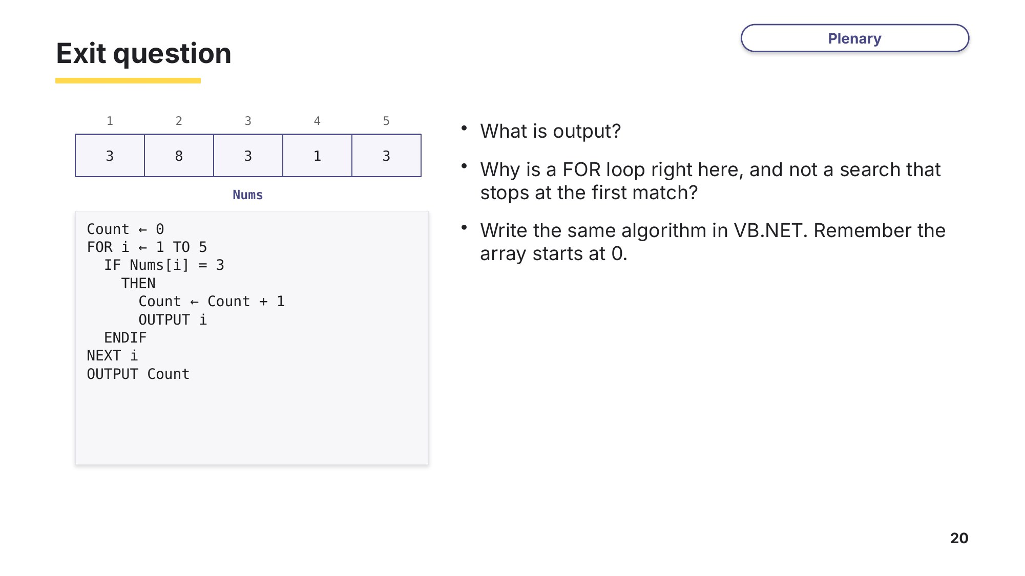
Slide 20 - Exit question

